**Data Structure and Algorithms**

**Data Structures –** These are like the ingredients you need to build efficient algorithms. These are the ways to arrange data so that they (data items) can be used efficiently in the main memory.

Examples: Array, Stack, Linked List, and many more. You don't need to worry about these names. These topics will be covered in detail in the upcoming tutorials.

**Algorithms –** Sequence of steps performed on the data using efficient data structures to solve a given problem, be it a basic or real-life-based one.

Examples include: sorting an array.

**Database** – Collection of information in permanent storage for faster retrieval and updation.

Examples are MySql, MongoDB, etc.

**Data warehouse** – Management of huge data of legacy data( the data we keep at a different place from our fresh data in the database to make the process of retrieval and updation fast) for better analysis.

**Big data** – Analysis of too large or complex data, which cannot be dealt with the traditional data processing applications.

**Memory Layout of C Programs:**

When the program starts, its code gets copied to the main memory.

* The stack holds the memory occupied by functions. It stores the activation records of the functions used in the program. And erases them as they get executed.
* The heap contains the data which is requested by the program as dynamic memory using pointers.
* Initialized and uninitialized data segments hold initialized and uninitialized global variables, respectively.

Take a look at the below diagram for a better understanding:

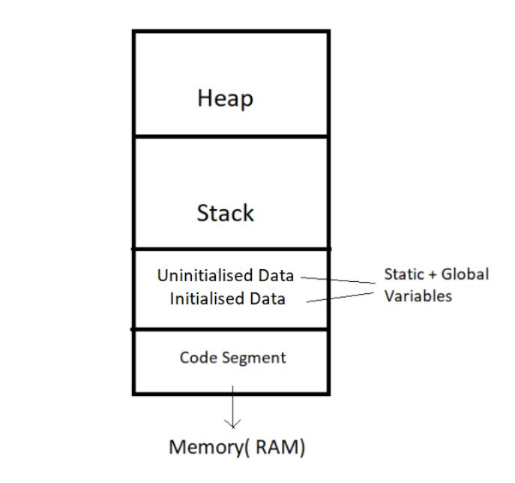

**Time Complexity and Big O Notation**

**What is Time Complexity?**

Time Complexity is the study of the efficiency of algorithms.

It tells us how much time is taken by an algorithm to process a given input.

Consider two developers Yatharth and Riya, who created an algorithm to sort ‘n’ numbers independently. When I made the program run for some input size n, the following results were recorded:

|  |  |  |
| --- | --- | --- |
| **No. of elements (n)** | **Time Taken By Riya’s Algo** | **Time Taken By Yatharth’s Algo** |
| 10 elements | 90 ms | 122 ms |
| 70 elements | 110 ms | 124 ms |
| 110 elements | 180 ms | 131 ms |
| 1000 elements | 2s | 800 ms |

We can see that at first, Riya’s algorithm worked well with smaller inputs; however, as we increase the number of elements, Yatharth’s algorithm performs much better.

**Calculating Order in terms of Input Size:**

In order to calculate the order(time complexity), the most impactful term containing n is taken into account (Here n refers to Size of input). And the rest of the smaller terms are ignored.

Let us assume the following formula for the algorithms in terms of input size n:

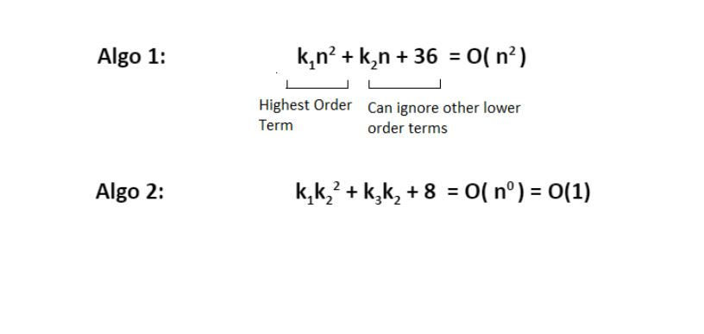

Here, we ignored the smaller terms in algo 1 and carried the most impactful term, which was the square of the input size. Hence the time complexity became n^2. The second algorithm followed just a constant time complexity.

Note that these are the formulas for the time taken by their program.

**What is a Big O?**

Putting it simply, big O stands for ‘order of’ in our industry, but this is pretty different from the mathematical definition of the big O. Big O in mathematics stands for all those complexities our program runs in. But in industry, we are asked the minimum of them. So this was a subtle difference.

**Visualizing Big O:**

If we were to plot O(1) and O(n) on a graph, they would look something like this:

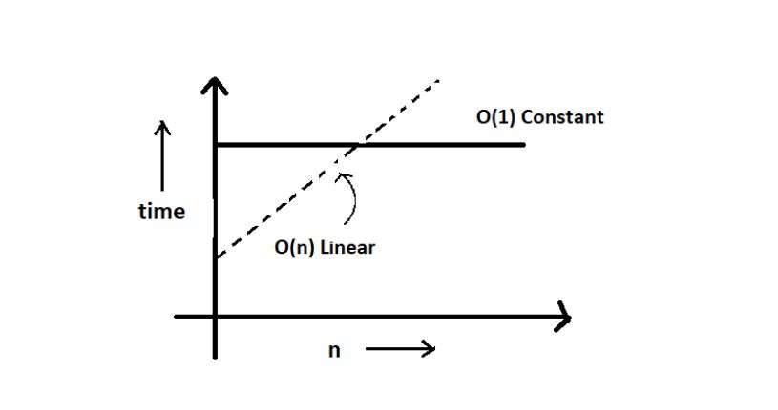

**Asymptotic Notations: Big O, Big Omega and Big Theta**

Now let's look at the mathematical definition of 'order of.' Primarily there are three types of widely used asymptotic notations.

Big oh notation ( O )

Big omega notation ( Ω )

Big theta notation ( θ ) – Widely used one

**Big oh notation ( O ):**

Big oh notation is used to describe an asymptotic upper bound.

Mathematically, if f(n) describes the running time of an algorithm; f(n) is O(g(n)) if and only if there exist positive constants c and n° such that:

0 ≤ f(n) ≤ c g(n) for all n ≥ n°.

Here, n is the input size, and g(n) is any complexity function, for, e.g. n, n2, etc. (It is used to give upper bound on a function)

If a function is O(n), it is automatically O(n2) as well! Because it satisfies the equation given above.

**Graphic example for Big oh ( O ):**

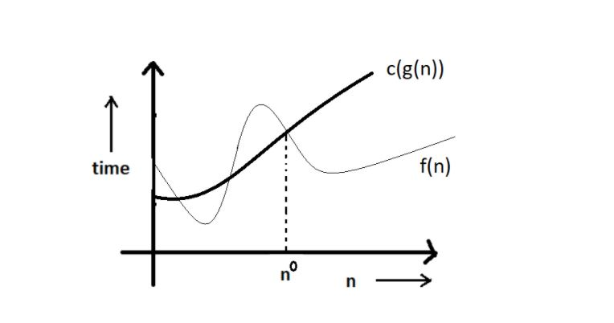

**Big Omega Notation ( Ω ):**

Just like O notation provides an asymptotic upper bound, Ω notation provides an asymptotic lower bound.

Let f(n) define the running time of an algorithm; f(n) is said to be Ω (g(n)) if and only if there exist positive constants c and n° such that:

0 ≤ c g(n) ≤ f(n) for all n ≥ n°.

It is used to give the lower bound on a function.

If a function is Ω (n2) it is automatically Ω (n) as well since it satisfies the above equation.

**Graphic example for Big Omega (Ω):**

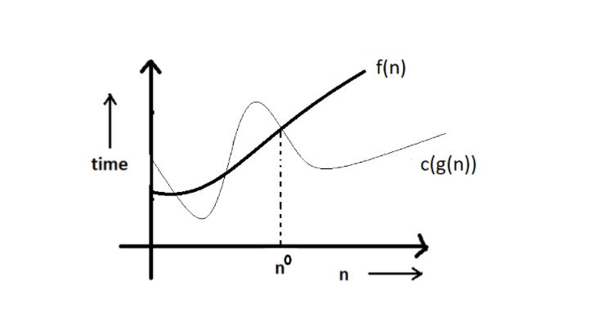

**Big theta notation ( θ ):**

Let f(n) define the running time of an algorithm.

F(n) is said to be θ (g(n)) if f(n) is O (g(n)) and f(x) is Ω (g(n)) both.

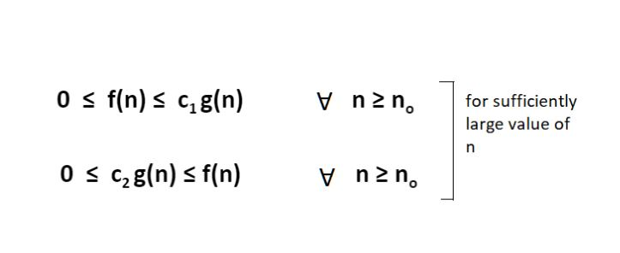

Merging both the equations, we get:

0 ≤ f(n) ≤ c g(n) for all n ≥ n°.

The equation simply means that there exist positive constants c1 and c2 such that f(n) is sandwiched between c2 g(n) and c1 g(n).

**Graphic example of Big theta ( θ ):**

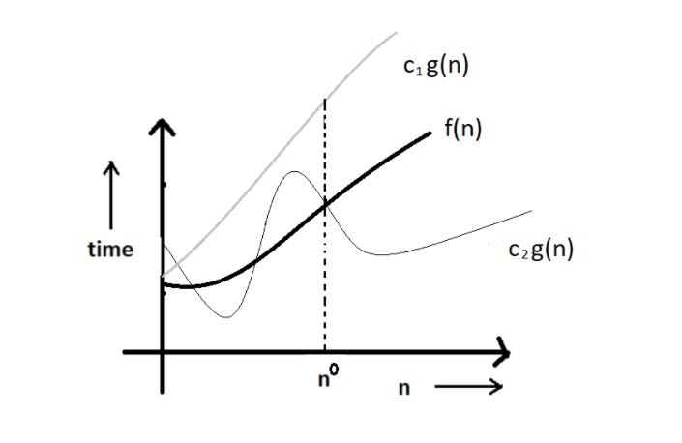

**Which one of these to use?**

Big theta provides a better picture of a given algorithm's run time, which is why most interviewers expect you to answer in terms of Big theta when they ask "order of" questions. And what you provide as the answer in Big theta, is already a Big oh and a Big omega. It is recommended for this reason.